**Assignment 1**

**Draw your Home Network Topology and explain how you access the RPS Lab environment.**

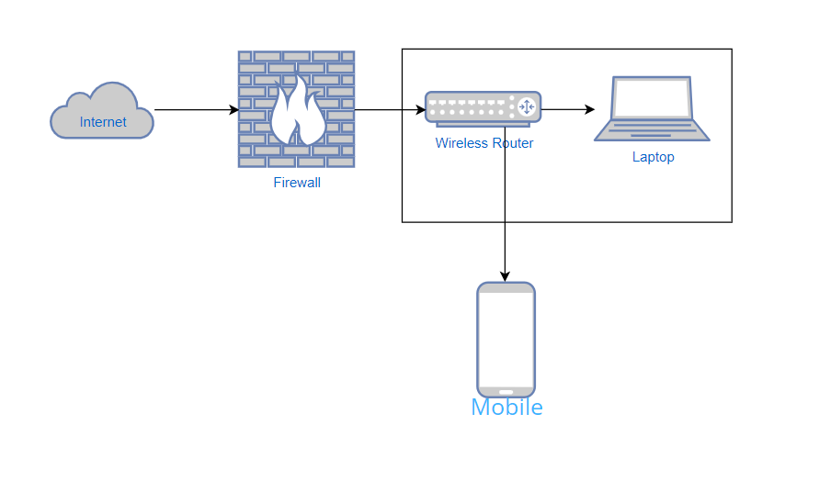

**Explanation:**

To access a cloud service using your laptop, you typically follow these steps:

**Internet Connection:**

Ensure your laptop is connected to the internet. You can connect via Wi-Fi or Ethernet, depending on your network setup.

**Open Web Browser:**

Open your preferred web browser on your laptop (e.g., Chrome, Firefox, Edge).

**Navigate to Cloud Provider's Website:**

Enter the URL of the cloud service provider you want to access (e.g., AWS, Azure, Google Cloud) in the address bar of your web browser.

Press Enter to go to the provider's homepage.

**Sign In to Cloud Account:**

Look for the "Sign In" or "Log In" option on the cloud provider's homepage and click on it.

Enter your cloud account credentials (username and password) and click "Sign In" to log in to your cloud account.

**Access Cloud Console or Dashboard:**

After logging in, you'll typically land on the cloud provider's console or dashboard. This is the central interface where you can manage your cloud resources.

Depending on the provider, you may see options like "Services," "Resources," or "Dashboard" to navigate to different areas.

**Navigate to Specific Services or Resources:**

Use the navigation menu or search bar within the cloud console to find and access the specific services or resources you need.

For example, you might access virtual machines, databases, storage, networking services, or developer tools.

**Manage and Use Cloud Resources:**

Once you're in the desired service or resource section, you can manage, configure, and utilize your cloud resources.

This may involve creating virtual machines, deploying applications, managing databases, configuring storage, setting up networking, etc.

**Monitor and Control:**

Use the monitoring and management features provided by the cloud platform to monitor the performance, usage, and costs of your cloud resources.

Set up alerts, manage permissions, and ensure security best practices are followed.

**Log Out and Secure Your Session:**

When you're done using the cloud services, log out of your cloud account to secure your session.

Follow any additional security measures recommended by the cloud provider, such as enabling multi-factor authentication (MFA) for added security.

By following these steps, you can effectively access and utilize cloud services using your laptop. The process may vary slightly depending on the cloud provider and the specific services you're using, but the general workflow remains similar across most cloud platforms.